Public Notice
  - 19 October 2023

Special Council Meeting
Notice is hereby given, pursuant to section 5.5(2) of the Local Government Act 1995 of a Special Council Meeting to be held, the details of which are as follows:

Date: Wednesday, 25 October 2023
Time: 1:15pm
Venue: Clem Thompson Sports Pavilion, Stadium Road, Tom Price, WA 6751

The purpose of the meeting is to consider the following items:
- Election of Deputy Shire President
- Appointment of elected members to Committees of Council
- Appointment of elected members to Working Groups and External Groups.

A swearing in ceremony for new elected members will be held at 12:45pm, prior to the Special Council Meeting.

The Special Council Meeting agenda will be published on the Shire’s website on Friday, 20 October 2023.
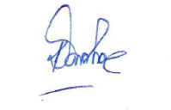

Kenn Donohoe
Chief Executive Officer

